Chapter 19, Solution 76.

To get z₁₁ and z₂₁, we open circuit the output port and let I₁ = 1A so that
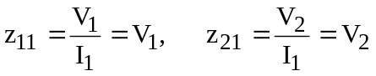

The schematic is shown below. After it is saved and run, we obtain

Similarly, to get z₂₂ and z₁₂, we open circuit the input port and let I₂ = 1A so that

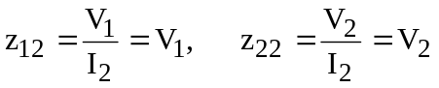

The schematic is shown below. After it is saved and run, we obtain

Thus,

